1.What will come in the place of question mark in following number series:

9.8, ?, 8.9, 11.6, 8, 12.5

1. 10.7

2. 11.7

3. 10.5

4. 10.9

5. 11.3

Solution:

Pattern of series –

?= 9 .8 + 0.9 = 10.7

10.7 - 1.8 = 8.9

8.9 + 2.7 = 11.6

11.6 - 3.6 = 8

8 + 4.5 = 12.5

2.What will come in the place of question mark in following number series:

400, 274, 209, 181, 172, ?

1. 169

2. 173

3. 168

4. 171

5. 170

Solution:

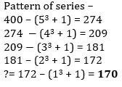

3.What will come in the place of question mark in following number series:

1, 1, ?, 15, 105, 945

1. 2

2. 3

3. 4

4. 1.5

5. 2.5

Solution:

Pattern of series –

1 ×1=1

? = 1 ×3= 3

3 ×5=15

15 ×7 = 105

105 ×9=945

4.What will come in the place of question mark in following number series:

12, ?, 6, 9, 18, 45

1. 15

2. 8

3. 6

4. 12

5. 4

Solution:

Pattern of series –

12 ×0.5=6

6 ×1=6

6 ×1.5 = 9

9 ×2=18

18 ×2.5=45

5.What will come in the place of question mark in following number series:

34, 18, 10, 6, ?, 3

1. 9

2. 4

3. 3

4. 2

5. 6

Solution:

Pattern of series –

34 ÷2+1=18

18 ÷2+1=10

10 ÷ 2+1=6

? = 6 ÷2+1= 4

4 ÷2+1=3

6.What will come in the place of the question mark (?) in the following number series?

2, 3, 7, 25, 121, ?

1. 719

2. 721

3. 723

4. 725

5. 726

Solution:



7.What will come in the place of the question mark (?) in the following number series?

5, 19, 45, 95, ?, 387

1. 187

2. 189

3. 191

4. 193

5. 195

Solution:



8.What will come in the place of the question mark (?) in the following number series?

2, 8, 20, 56, 200, ?

1. 880

2. 890

3. 900

4. 910

5. 920

Solution:

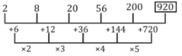

9.What will come in the place of the question mark (?) in the following number series?

32, 32, 16, 48, 12, ?

1. 60

2. 55

3. 72

4. 66

5. 54

Solution:



10.What will come in the place of the question mark (?) in the following number series?

6, 10, 19, 27, 54, ?

1. 66

2. 68

3. 70

4. 72

5. 74

Solution:

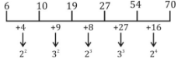

11.What will come in the place of the question mark (?) in the following number series?

1, 0, 1, 16, 81, ?, 625

1. 196

2. 121

3. 256

4. 100

5. 225

Solution:

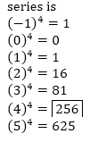

12.Find the wrong number in the following number series.

158, 156, 168, 148, 176, 140, 184

1. 158

2. 148

3. 140

4. 156

5. 176

Solution:

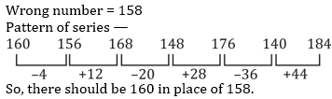

13.Find the wrong number in the following number series.

3, 3, 9, 45, 313, 2835, 31185

1. 31185

2. 9

3. 313

4. 2835

5. 45

Solution:Wrong number = 313

Pattern of series —

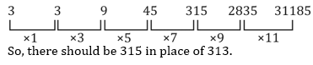

14.Find the wrong number in the following number series.

10, 260, 480, 685, 860, 1010, 1135

1. 1010

2. 860

3. 260

4. 10

5. 480

Solution:Wrong number = 480

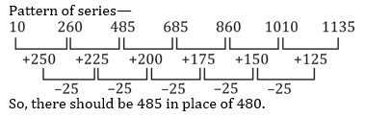

15.Find the wrong number in the following number series.

229, 240, 257, 280, 311, 352, 400

1. 229

2. 400

3. 257

4. 311

5. 352

Solution:Wrong number = 400

Pattern of series —

229 + 11 = 240

240 + 17 = 257

257 + 23 = 280

280 + 31 = 311

311 + 41 = 352

352 + 47 = 399

So, there should be 399 in place of 400. (Alternate prime number)

16.Find the wrong number in the following number series.

1201, 1200, 1197, 1188, 1161, 1082, 837

1. 1200

2. 1188

3. 837

4. 1201

5. 1082

Solution:Wrong number = 1082

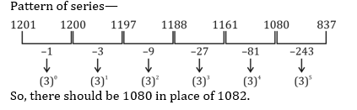

**17.** What will come in place of (?) in the following questions?

100, 97, 92, 83, 68, ?

1. 54

2. 45

3. 49

4. 57

5. 60

Solution:

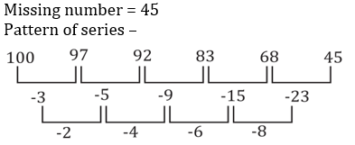

**18.** What will come in place of (?) in the following questions?

12, 129, 233, 324, ?, 467

1. 400

2. 405

3. 412

4. 409

5. 402

Solution:

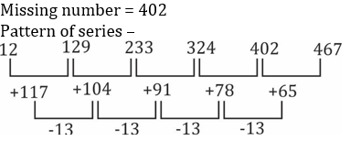

**19.** What will come in place of (?) in the following questions?

0.75, ?, 3, 6, 12, 24

1. 1.5

2. 2

3. 1

4. 1.25

5. 1.75

Solution:

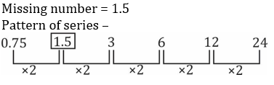

**20.** What will come in place of (?) in the following questions?

8, ?, 4, 6, 12, 30

1. 5.5

2. 4.5

3. 5

4. 4

5. 6

Solution:

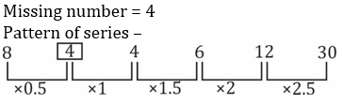

**21.** What will come in place of (?) in the following questions?

1, 2, 5, 16, 65, ?

1. 330

2. 315

3. 326

4. 320

5. 316

Solution:

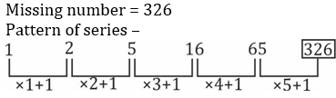

22.What should come in place of the question mark (?) in the following series ?



1. 222

2. 262

3. 244

4. 272

5. None of these

Solution:

**23.** What should come in place of the question mark (?) in the following series ?



1. 9981

2. 8281

3. 7321

4. 9876

5. 9978

Solution:

**24.** What should come in place of the question mark (?) in the following series ?



1. 18

2. 20

3. 21

4. 24

5. 26

Solution:

**25.**What should come in place of the question mark (?) in the following series ?



1. 83

2. 88

3. 94

4. 97

5. 100

Solution: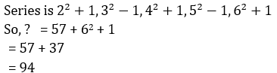

**26.** What should come in place of the question mark (?) in the following series ?



1. 480

2. 256

3. 216

4. 512

5. 420

Solution: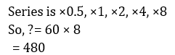

What should come in place of question mark (?) in the following number series?

27.3, 5, 15, 45, 113, ?

1. 190

2. 234

3. 293

4. 243

5. 208

Solution: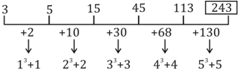

**28.** What should come in place of question mark (?) in the following number series?

17, 98, 26, 89, 35, ?

1. 78

2. 79

3. 80

4. 81

5. 82

Solution: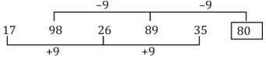

**29.**What should come in place of question mark (?) in the following number series?

3240, 540, 108, 27, ?, 4.5

1. 12

2. 7

3. 9

4. 8

5. 6

Solution: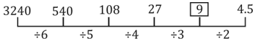

**30.**What should come in place of question mark (?) in the following number series?

7, 4.5, 5.5, 12, 49, ?

1. 393

2. 378

3. 197

4. 148

5. 246

Solution: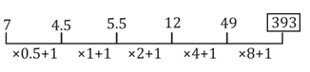

**31.** What should come in place of question mark (?) in the following number series?

2, 17, 89, 359, 1079, ?

1. 2134

2. 1081

3. 2195

4. 2159

5. 1945

Solution: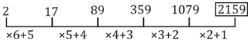

32.Find the wrong number in the following number series:

4, 5.1, 7.3, 10.6, 15, 20, 27.1

1. 5.1

2. 4

3. 7.3

4. 20

5. 27.1

Solution:

**33.** Find the wrong number in the following number series:

2, 3, 8, 31, 154, 924, 6460

1. 924

2. 6460

3. 154

4. 8

5. 31

Solution:

**34.** Find the wrong number in the following number series:

251, 252, 254, 227, 243, 118, 154

1. 251

2. 252

3. 227

4. 243

5. 154

Solution: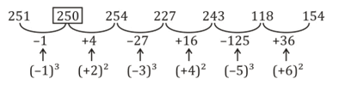

**35.** Find the wrong number in the following number series:

141, 156, 147, 162, 153, 165, 159

1. 156

2. 153

3. 147

4. 165

5. 159

Solution:

**36.**Find the wrong number in the following number series:

2, 6, 10, 19, 36, 69, 134

1. 134

2. 69

3. 6

4. 2

5. 10

Solution: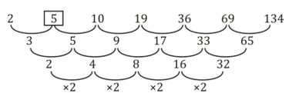

**37.** Find the wrong number in the following number series:

0.5, 2, 1, 4, 32, 512, 16384

1. 1

2. 2

3. 4

4. 32

5. 512

Solution:

38.What will come in place of the question mark (?) in the following number series ?

8, 10, 18, 44, 124, (?)

1. 344

2. 366

3. 354

4. 356

5. None of these

Solution:

The pattern of the number series is :

8 + 2 = 10

10 + 8 (= 2 × 3 + 2) = 18

18 + 26 (= 3 × 8 + 2) = 44

44 + 80 (=3 × 26 + 2) = 124

124 +242 (= 3 × 80 + 2) = 366

**39.** What will come in place of the question mark (?) in the following number series ?

13, 25, 61, 121, 205, (?)

1. 323

2. 326

3. 324

4. 313

5. None of these

Solution:

The pattern of the number series is :

13 + 1 × 12 = 13 + 12 = 25

25 + 3 × 12 = 25 + 36 = 61

61 + 5 × 12 = 61 + 60 = 121

121 + 7 × 12 = 121 + 84 = 205

205 + 9 × 12 = 205 + 108 = 313

**40.** What will come in place of the question mark (?) in the following number series ?

656, 352, 200, 124, 86, (?)

1. 67

2. 59

3. 62

4. 57

5. None of these

Solution:

The pattern of the number series is :

656/2 + 24 = 328 + 24 = 352

252/2 + 24 = 176 + 24 = 200

200/2 + 24 = 100 + 24 = 124

124/2 + 24 = 62 + 24 = 86

86/2 + 24 = 43 + 24 = 67

**41.** What will come in place of the question mark (?) in the following number series ?

454, 472, 445, 463, 436, (?)

1. 436

2. 456

3. 454

4. 434

5. None of these

Solution:

The pattern of the number series is :

454 + 18 = 472

472 - 27 = 445

445 + 18 = 463

463 - 27 = 436

436 + 18 = 454

**42.** What will come in place of the question mark (?) in the following number series ?

12, 18, 36, 102, 360, (?)

1. 1364

2. 1386

3. 1384

4. 1376

5. None of these

Solution:

The pattern of the number series is :

12 × 4 - 30 = 48 - 30 = 18

18 × 4 - 36 = 72 - 36 = 36

36 × 4 - 42 = 144 - 42 = 102

102 × 4 - 48 = 408 - 48 = 360

360 × 4 - 54 = 1440 - 54 = 1386